**VARUN KUMAR**

**2K19-IT-140**

**OOP LAB – 7**

**1) WAP to show const in the following cases:**

**Const variable, function, object, const pointer, pointer to const**

**#include <iostream>**

**using namespace std;**

**class student{**

**const string college; //constant variable**

**string name;**

**public:**

**student(string n):college("DELHI TECHNOLOGICAL UNIVERSITY")**

**{**

**cout<<"DECLARED CONSTANT variable for "<<n<<" \n";**

**name=n;**

**}**

**void print_college() const //constant function**

**{**

**cout<<college<<endl;**

**}**

**};**

**int main()**

**{**

**const student s1("STUDENT 1"); //constant object**

**s1.print_college();**

**student s2("STUDENT 2");**

**s2.print_college();**

**student * const ptr1 = &s2; // constant pointer**

**const student * ptr2 = &s1; // pointer to a constant**

**// ptr1=&s1;**

**return 0;**

**}**

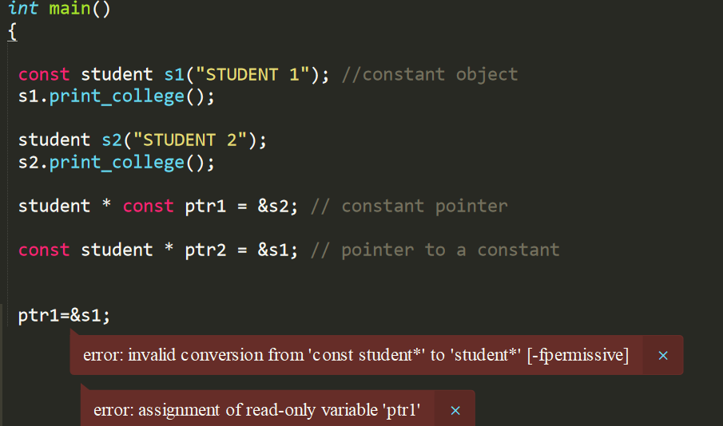

**ERROR WHILE CONSTANT POINTER MODIFIES**

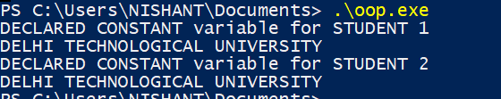

**2 ) Write a c++ program to make use of object array for a class and swap the values of alternate**

**objects.**

**Eg: take 10/even number of objects in array.**

**Get/set their values using constructor(s)**

**Create a swap function taking objects as arguments swap(s[0],s[1]), swap(s[2],s[3])… so on**

**After that print their swapped values**

**Use const/static to support the code.**

**NOTE: try to make the code generic.**

**#include <iostream>**

**using namespace std;**

**class student{**

**int roll_no;**

**string name;**

**public :**

**student(int d=-1,string n="UNKNOWN")**

**{**

**roll_no=d;**

**name=n;**

**}**

**void print() const**

**{**

**cout<<"roll_no:\t"<<roll_no<<endl;**

**cout<<"NAME:\t"<<name<<endl;**

**}**

**};**

**void swap(student &s1,student &s2)**

**{**

**student temp=s1;**

**s1=s2;**

**s2=temp;**

**}**

**int main()**

**{**

**int size=5;**

**student a[size]={ student(140,"varun"),student(122,"VANSH"),student(100,"RAHUL"),student(125,"PIYUSH"),student(151,"VEDANT")};**

**for(int i=0;i<size;i+=2)**

**{**

**if(i+1<size)**

**swap(a[i],a[i+1]);**

**}**

**for(int i=0;i<size;i++)**

**a[i].print();**

**return 0;**

**}**

